
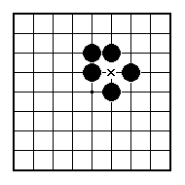
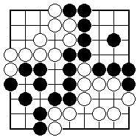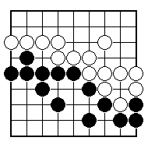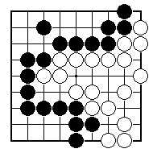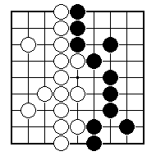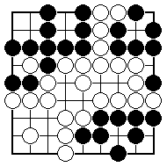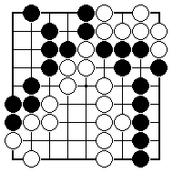
There is only worthwhile place for Black to play. Where is it?

There is only worthwhile place for Black to play. Where is it?

Is this game finished, apart from neutral points?

Is this game finished, apart from neutral points?

Black to play. Where is biggest?

Which two points are worth playing and which should White play first?

NAME:
BRITISH GO ASSOCIATION CERTIFICATE LEVEL 3 - SHEET 2

ENDGAME POSITIONS

